HORTON PARISH COUNCIL ___________________________________________________________________

MINUTES OF THE ANNUAL PARISH MEETING HELD ON:
Date & Time: Thursday 8th May 2025 at 6.30pm
Venue: Broadway Hill Methodist Church

- ATTENDANCE Councillors Barry Mosley – Chair, Ann Winter, Mike Schmidt, Julie Layzell, Hannah Massey and Jack Martin.

APOLOGIES Cllrs Andy Johnson – Vice-Chair, Peter Babbington and Robert Hutchinson.
- TO SIGN THE MINUTES OF THE LAST ANNUAL PARISH MEETING Minutes of the meeting held in May 2024, having previously been circulated, were approved as a true and correct record of the meeting.
- TO RECEIVE THE CHAIRPERSON’S REPORT A report was not given.
- COMMENTS AND QUESTIONS ON THE CHAIRPERSON’S REPORT n/a.
- TO RECEIVE THE REPORTS OF THE LOCAL ORGANISATIONS
- Police – Not in attendance at the meeting, but would like to attend a future meeting.
- The Tree Warden – Representative was in attendance at the meeting, but no formal update or report was given.
- Methodist Church - Report of the church was not available. Representative advised the church is very happy with events in the church for the community, grateful for the understanding neighbours. The church is planning to apply for grants for the West Wall rendering, and for a stairlift to enable volunteers for the Shoe box project, the Children's Contact Centre and the youth club to access storage.
- St Peter's Church – Please refer to Appendix 1.
- Neroche Primary School – Not in attendance at the meeting, but would like to attend a future meeting.
- Ding Gardening Club – Representative was in attendance at the meeting, but no formal update or report was given.
- Ramblers Walking Group – Cllr Ann Winter provided an update, this September it has been going for 26 years. Walkers pay £2per walk. £Dates and walks advertised in the Horton Gazette. The length of walks is around 5 miles.
- Cricket Club – A representative was in attendance at the meeting. Village hall renovations and extensions are now complete. The committee and members were thankful for the support and grant funding from the parish council.
- Village Hall – Cllr Ann Winter provided an update. Very busy and the calendar is full. People's feedback says how impressed they are with the hall. A defibrillator has been installed.
- Women’s Institute – Not in attendance at the meeting, no report received.
- Ilton and Broadway Scouts – Not in attendance at the meeting, no report received.
- Horton Charity – Cllr Ann Winter provided an update. No recent requests. Still a small amount of money available.
- Horton and Broadway Youth Club - Not in attendance at the meeting, no report received.
- ANY PARISH ITEMS YOU MAY WISH TO DISCUSS, BY LAW AND PASS RESOLUTIONS ON THEM There were no parish items to be discussed and therefore no resolutions passed.

Meeting closed: 18:46

APPENDIX 1 – ST PETERS CHURCH

The Church of St Peter, Horton

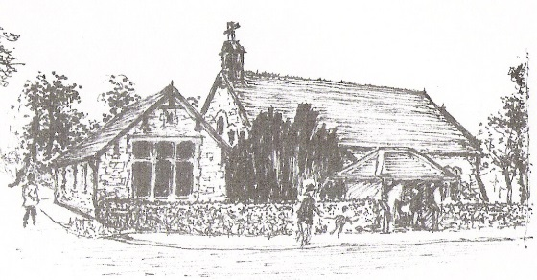
Rector: Revd. Philip Albrow

Churchwarden Treasurer Secretary
Mrs J S Allen Mrs C Trueman Mr R G Allen
4 Slades Orchard Woodstock 4 Slades Orchard
Horton Church Lane Horton
TA19 9SQ Horton TA19 9RN TA19 9SQ
Tel No 01460 57702 Tel No 01460 259361 Tel No 01460 57702
7th May 2025

Dear Charlotte,

St Peter’s Church, Horton – Report to Horton Parish Council for 2024
Regrettably, I broke my foot in March 2024, and was incapacitated for 6 months
Our Church was opened every day in 2024 from 10.00am – 4.00pm

Our fundraising in 2024 was successful - Lent Lunches, a quiz, and our meat draw on the run
up to Christmas.

We remain grateful to Horton Parish Council for their continued support, in awarding us a £450 grant last year towards the upkeep of the Parish graveyard. For those of you who have
visited the Churchyard you can see how well kept it is.

Our costs to run St Peter’s Church, Horton is £22,000.00 which for a small rural Church is quite
a challenge

We were pleased to hold our Christmas services including Advent Carols, Nativity, Christmas
tree lighting, our Carol Service, collection of which was donated to the Children’s Hospice
South West, and our Christingle collection was donated to the Children’s Society.

It is my pleasure, and honour to be Churchwarden, and I am happy to continue to be so all the
while I am needed, and feel well enough to continue. Best wishes
Jan
Jan Allen
Churchwarden – The Church of St Peter, Horton

Mrs Charlotte Duff
Parish Clerk – Horton Parish Council

